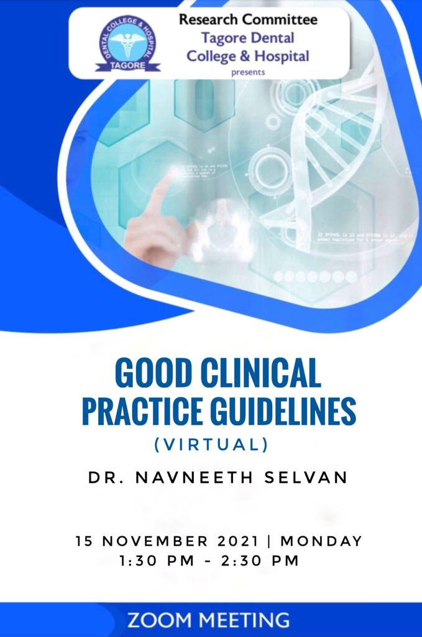DEPARTMENT OF ORAL AND MAXILLOFACIAL SURGERY
TAGORE DENTAL COLLEGE AND HOSPITAL
MELAKOTTAIYUR POST, RATHINAMANGALAM
CHENNAI – 600127
PH: 044 – 3010 2222, EXTN: 228 / 230
EMAIL ID: maxfacs@tagoredch.in

PROF.M.MALA DR.C.J.VENKATAKRISHNAN
CHAIRPERSON PRINCIPAL
ORGANIZING COMMITTEE:
PROF.DR.S.JIMSON
DR.B.LOKESH
DR.B.ANANDH
DR.BALAKRISHNA
DR.MEERAN SHARIF
DR.ISRAEL NATHANAEL
DR.JONES JAYABALAN
DR.JEDIDIAH

ORGANIZER:
Department of Oral & Maxillofacial Surgery
Tagore Dental College & Hospital

Date: NOVEMBER 15TH 2021

LEARNING OUTCOME:
To acquire detailed knowledge on good clinical practice.

VENUE: Conducted online through official GOOGLE MEET application.

GUEST SPEAKERS:
1. Dr.NAVNEETH SELVAN
ICMR

TOPICS COVERED:
1. Current challenges for integrative health care
2. Principles of good clinical practice.
The program started with the welcome note by the Organizing chairman, Prof.Dr.S.Jimson. The lecture session started by 1.00pm. It was a detailed and very informative lecture on “good clinical practice”. A discussion session and question and answer session was followed by the lecture.The program ended with the vote of thanks by Dr.B.Anandh.
PROGRAM FEEDBACK:
The program was attended by 69 participants. The program received a Excellent feedback from the participants.

PICTURES:
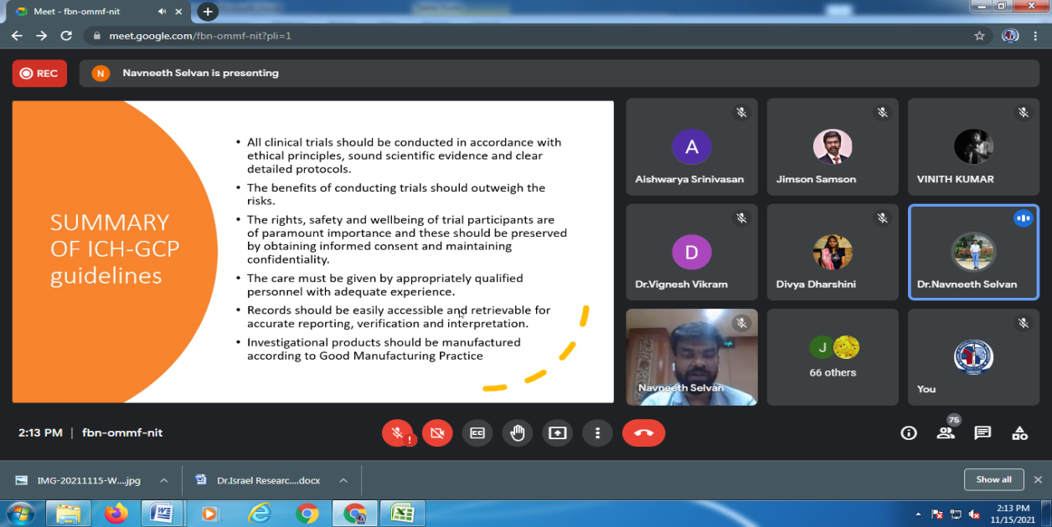

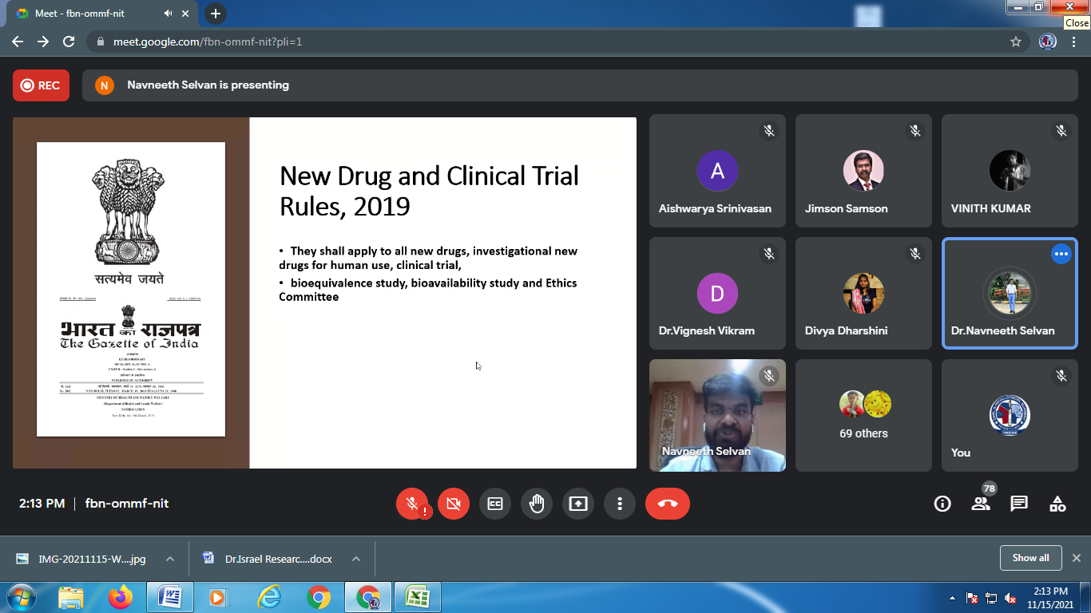

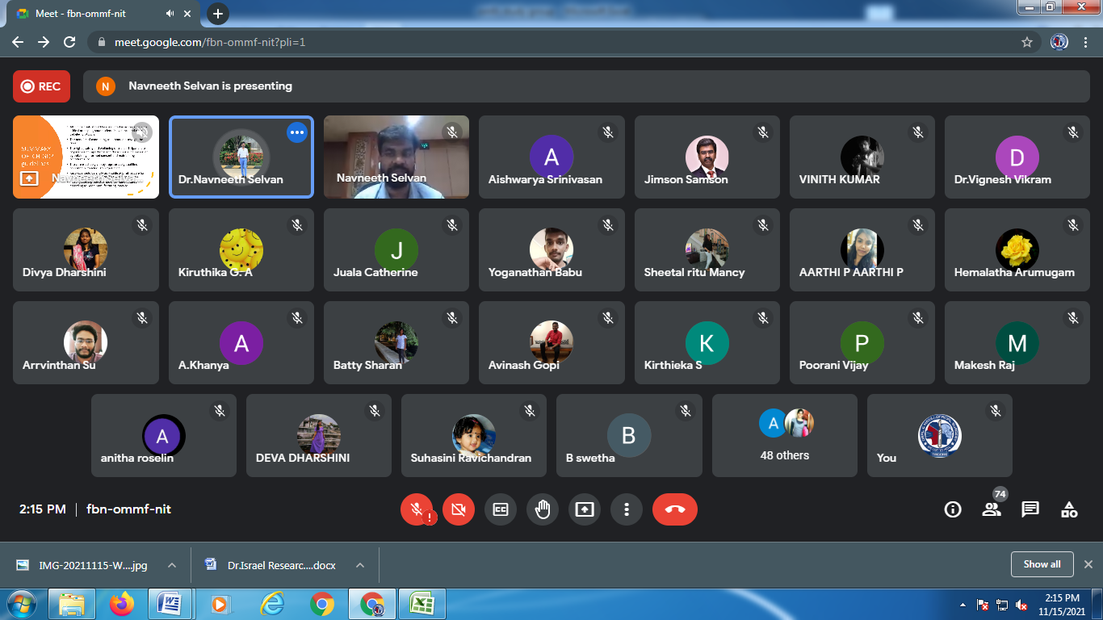

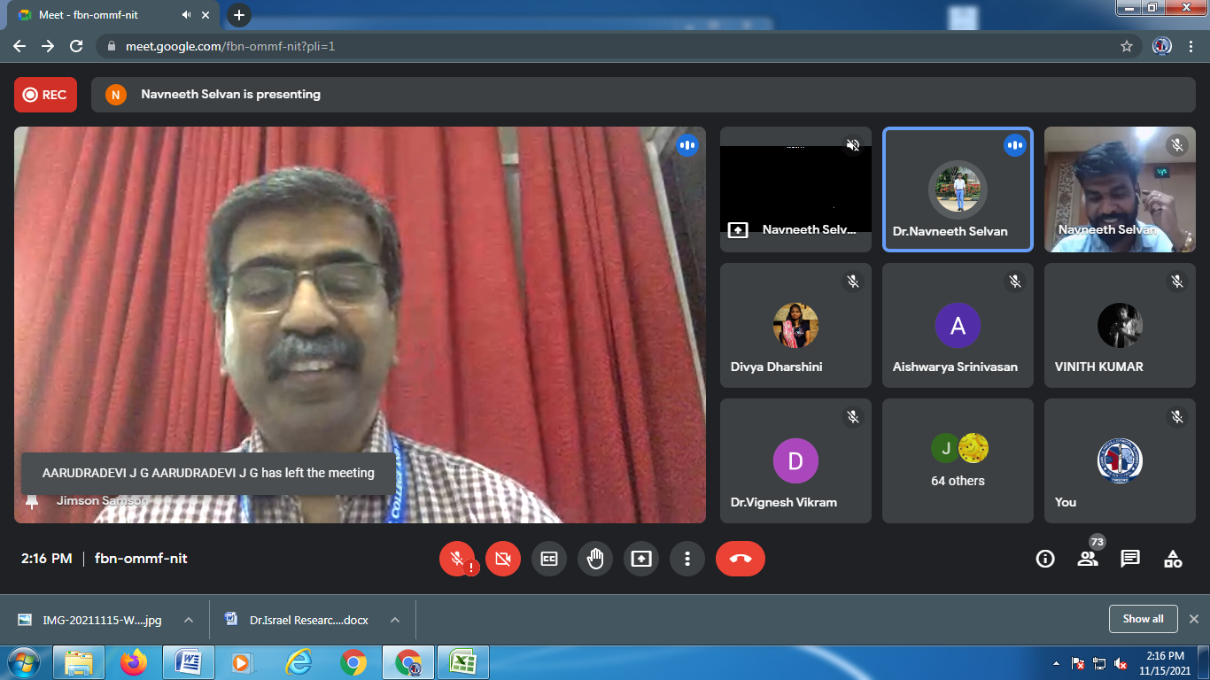

ATTENDANCE SHEET :
P.AARTHI | C. CHARANYA | M.NIVETHA | POORANI.V | SUHASINI | KHANYA A
G.ELAKIYA | VARSHINI. C | HARSHA VARDHAN P | HARSHITHA BALAJI | S.ANITHA ROSELIN | HANISHA SELVAN
G.PREETHA | SUDARSHAN | DR.HEMALATHA ARUMUGAM | M.GEETHANJALI | G BHUVANA | DEEPIKA. R
DR.DHATSHAYANI.C | SIVARANJANI S | S SARATH SARATHY | ARSHA JOHNY | A. BHARGAVI | BATTY SHARAN.R
GOWTHAM S T | RAGAVI.R | N. GEETHA PRIYA | SURYA N G | DINAKAR R | NARASIMMAN
BHUVANESWARI B | ABINAYA THIRUNAVUKKARASU | KEERTHI P | DHAMINI. P. M. | NIKKIN ACHARYA | DEVIKA S NAIR
SHOBANA C S | SARAH E | ISWARYA. K | DIWAKAR.J | MAHALAKSHMI. K | DURGA.G
BHARATH KUMAR B | V.JAI SANTHOSH MANIKANDAN | VINITH KUMAR | S.AKKSHAYA | KEERTHI P | LOGESH.R
R DEVADHARSHINI | SHANTHINI PRIYA A | T. V. VASANTHA BHARATHY | M ANISHA SEBATNI | MARSHAL | DR. PARVATHI S
BLESSY R | AARUDRA DEVI JG | NANDHINI S | E.YOGANATHAN | KEETHANA R | DIVYA DHARSHINI K
KRISHANGA SRIVASTAVA | AJITH G | P.KAVITHA | AKHILESHWARAN.R | N.DEVA KUMAR | JUALA CATHERINE
AVINASH.G | DR.VIGNESH VIKRAM | - | - | -- | -

